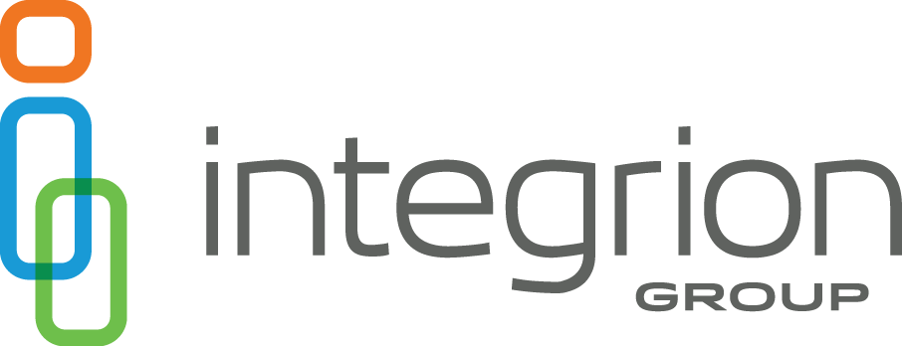

Job Title: Workers' Compensation Claims Manager
Department: Workers' Compensation
Reports to: Director of Operations

Position Summary: The Workers’ Compensation Claims Manager oversees the Workers’ Compensation Insurance Claims Department at Integrion Group. This role ensures that all claims are handled and settled in compliance with applicable laws, industry best practices, and company procedures. The Claims Manager is responsible for maintaining high standards of service, compliance with the New Mexico Workers’ Compensation Administration and the Industrial Commission of Arizona, and ensuring that all operations are audit-ready.

Essential Functions:
- Claims Oversight: Assign and review claims, applying technical expertise and interpersonal skills to ensure fair settlements, prompt case resolution, and a reduced loss ratio.
- Team Leadership: Supervise and mentor Claims Adjusters, Technicians, and support staff. Conduct performance evaluations, set individual goals, and identify training needs to foster professional growth.
- Process Management: Develop, update, and enforce the claims operations manual and attorney guidelines. Ensure efficient processing and payment of claims.
- Compliance & Quality Assurance: Conduct regular claim file reviews and audits to ensure adherence to procedures, compliance with special account instructions, and accurate documentation of claim payments, reserves, and new claims.
- Recruitment & Onboarding: Lead hiring decisions for department staff, oversee new hire orientation, and ensure all team members receive comprehensive training and ongoing professional development.
- Claims Investigation: Review claims investigated by claims adjusters, verify data, and ensure adjudication aligns with client instructions, company policies, and state statutes. Investigate questionable claims and consult with the Director of Operations and/or legal counsel on litigation matters.
- Vendor & Cost Management: Review and approve vendor partners, identify cost-saving opportunities for clients, and recommend procurement strategies to executive management.
- Business Development: Represent Integrion Group at industry conferences and seminars, network with professionals, and identify new business opportunities. Provide recommendations to executive management and marketing on potential profit opportunities.
- Stakeholder Engagement: Build and maintain relationships with clients, management, vendor partners, and industry professionals. Represent the company in public forums and business meetings.
- Claims Adjusting: adjust workers’ compensation claims as needed.
- Other Duties: Perform additional responsibilities as assigned by management.

Job Qualifications:
Education and Experience Requirements:
- Education: Bachelor’s degree in Business Administration or a related field. Equivalent experience may be considered.
- Experience: Minimum of ten (10) years in insurance claims administration or a related field, including at least three (3) years in a supervisory role. Substitutions or exceptions may be authorized by Integrion management. Current New Mexico adjuster license required (or obtained within first 60 days).

Knowledge, Skills and Abilities:
- Strong knowledge of business and management principles, including strategic planning, resource allocation, and leadership techniques.
- Familiarity with customer service principles, quality standards, and customer satisfaction evaluation.
- Proficiency with electronic equipment, computer hardware, and software applications, including word processing and spreadsheets.
- Analytical skills to identify complex problems, evaluate options, and implement effective solutions.
- Ability to reconcile differences in claims and make sound decisions considering costs and benefits.
- Excellent interpersonal, oral, and written communication skills.
- Proven ability to build and maintain relationships across departments and with external stakeholders.
Values and Mission:
Demonstrate Integrion Group’s core values: Service Excellence, Trust, Ownership, One Team, and Boldness in thought and action.
Positive Attitude:
Foster positive working relationships with team members, customers, and management through effective communication and collaboration.

Working Conditions:
- General office environment with light to moderate physical demands.
- Adherence to all safety rules, building security protocols, and participation in maintaining safe and efficient operations.
- Drug-free workplace, with pre-employment and post-incident drug testing.
- Regular use of computer monitors and digital workstations.
Commitment to Diversity, Equity, and Inclusion:
Integrion Group is committed to creating a diverse and inclusive workplace. We encourage applicants from all backgrounds and experiences to apply.

