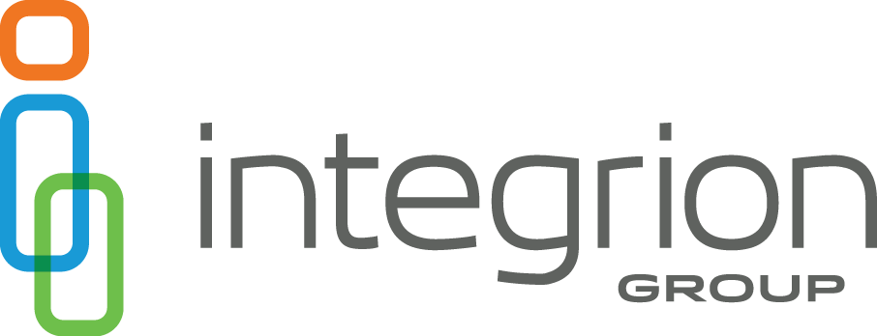
Job Title: Admin Clerk
Department: Administration
Reports to: Administration Supervisor

Position Summary: This position is responsible for assisting claims adjusters to include processing incoming documents and information by sorting, classifying and coding material for integration into software systems or into storage. The Administrative Assistant answers general telephone calls and routes to the appropriate personnel, processes new claim set-up for all clients, provides general administrative office support and performs other administrative tasks.

Essential Functions:
- Prepare written correspondence to include but not limited to: initial letter to injured worker, client acknowledgement, medical record release and request, form letter to healthcare provider, income verification form and closing letter.
- Prepares, scans, indexes and verifies documents in the imaging system.
- Maintains records of incoming claim files to be scanned and ensures that all files are scanned, viewable and organized.
- Reproduces files, either in hard copy or in electronic format, for sending to a third party.
- Assists in sorting, coding and distribution of incoming mail to appropriate party.
- Enters new claims into claims computer system and completes State filings via EDI to include FROI, PY/IP, CB and FN required by the New Mexico Workers’ Compensation Administration
- Prepares bill status email responses and healthcare provider claim status reviews via telephone, email, and written correspondence.
- Gathers and organizes outgoing mail and prepares for distribution.
- Receives calls to assist external and internal inquiries.
- Other duties as assigned

Job Qualifications:
Education: High school diploma or equivalency required.

Experience: A minimum of three years of office administration experience with workers’ compensation experience preferred.

Required Skills and Abilities:
- Strong communication skills both verbal and written
- Attention to detail and accuracy
- Ability to meet deadlines
- Ability to maintain and build relations with internal and external stakeholders
- Excellent organizational skills which include multi-tasking
- Must be a self-starter with the ability to work independently and as part of a larger team

Specialized Knowledge, Licenses, etc.:
- Proficient with MS Word, Excel, Claim Pilot, File Handler and Power Point

Values and Mission:
Adheres to values and mission by demonstrating Service Excellence, Trust, Ownership, One Team and Boldness in thought and action.

Positive Attitude:
Develops and maintains positive working relationships with team members, customers, co-workers and management by demonstrating effective communication and collaborative skills.

Working Conditions:
- Integrion Group maintains general office conditions with light physical demands.
- Employees of Integrion Group adhere to all safety rules and regulations including building security.
- Employees participate in ensuring safe and efficient operating conditions that safeguard employees and facilities.
- Integrion Group maintains a drug free environment; Successful candidates are drug-tested prior to employment as well as upon a work-related accident.
- Exposure to VDT screens.

